SQL Assignment 3

- Create a function and then call another function from within it. What is this process called?

CREATE FUNCTION fnItemTotal
(@ItemID INT )
RETURNS MONEY
BEGIN
RETURN
(
SELECT
ItemId,
(SELECT * FROM dbo.fnDiscountPrice(ItemID) WHERE ItemID=@ItemID)*Quantity)
--The fnDiscountPrice is the Other function i created.
FROM
OrderItems
WHERE
ItemID=@ItemID
);
END
GO

This is what to call it:

Select ItemID,dbo.fnItemTotal(ItemID) AS 'Total Price'
from OrderItems
ORDER BY ItemID;

- How to inspect the query's execution plan?

1.On the toolbar, click Database Engine Query. You can also open an existing query and display the estimated execution plan by clicking the Open File toolbar button and locating the existing query.
2.Enter the query for which you would like to display the estimated execution plan.
3.On the Query menu, click Display Estimated Execution Plan or click the Display Estimated Execution Plan toolbar button. The estimated execution plan is displayed on the Execution Plan tab in the results pane.
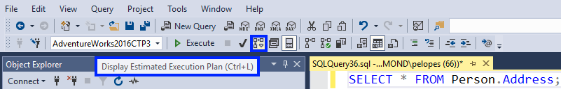
To view additional information, pause the mouse over the logical and physical operator icons and view the description and properties of the operator in the displayed ToolTip. Alternatively, you can view operator properties in the Properties window. If Properties is not visible, right-click an operator and click Properties. Select an operator to view its properties.
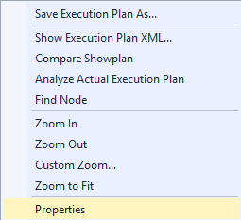

4.To alter the display of the execution plan, right-click the execution plan and select Zoom In, Zoom Out, Custom Zoom, or Zoom to Fit. Zoom In and Zoom Out allow you to magnify or reduce the execution plan by fixed amounts. Custom Zoom allows you to define your own display magnification, such as zooming at 80 percent. Zoom to Fit magnifies the execution plan to fit the result pane. Alternatively, use a combination of the CTRL key and your mouse wheel to activate dynamic zoom.
5.To navigate the display of the execution plan, use the vertical and horizontal scroll bars, or click and hold on any blank area of the execution plan, and drag your mouse. Alternatively, click and hold the plus (+) sign in the right lower corner of the execution plan window, to display a miniature map of the entire execution plan.

- What is the purpose of the MAXDOP and recompiling keywords in SQL queries?

The maximum degree of parallelism (MAXDOP) is a server configuration option for running SQL Server on multiple CPUs. It controls the number of processors used to run a single statement in parallel plan execution. The default value is 0, which enables SQL Server to use all available processors.

A recompilation is the same process as a compilation, just executed again. If the database structure or data change significantly, a recompilation is required to create a new query execution plan that will be optimal for the new database state and ensure better procedure performance.
A recompilation degrades SQL Server performance, as SQL Server is performing the same action multiple times, instead of using its resources for other important actions. If you could use the cached execution plan, instead of recompiling the stored procedure again, that would make query execution faster for the time needed for a recompilation.

- How to build DDL statements from an existing database table, write steps for it?

SQL DDL commands
The DDL commands in SQL are used to create database schema and to define the type and structure of the data that will be stored in a database. SQL DDL commands are further divided into the following major categories:
- CREATE
- ALTER
- DROP
- TRUNCATE

- How to update data in a table using an inner join, write an example?

UPDATE customer_table
INNER JOIN
Customer_table
ON customer_table.rel_cust_name = customer_table.cust_id
SET customer_table.rel_cust_name = customer_table.cust_name

- Differentiate between truncate, delete, and drop with a suitable example.

DELETE is a DML (Data Manipulation Language) command. This command removes records from a table. It is used only for deleting data from a table, not to remove the table from the database.

TRUNCATE TABLE is similar to DELETE, but this operation is a DDL (Data Definition Language) command. It also deletes records from a table without removing table structure, but it doesn’t use the WHERE clause.

The DROP TABLE is another DDL (Data Definition Language) operation. But it is not used for simply removing data from a table; it deletes the table structure from the database, along with any data stored in the table.

